One

Factors influencing waste generation, and guidance for how to measure waste reduction – An empirical approach
Corresponding Author: Dr. Calvin Lakhan
Secondary Author(s):
- Ryan Guild
- Kelsey Morgan
- Alex Christison

Prepared by: Waste Wiki@FES
Faculty of Environmental Studies, York University

Contents
The Issue with Weight Based Metrics 2
Systemic change 3
Endemic Characteristics 3
Attributional Change 5
Methodology 6
Data Sources 6
Regression Model 6
Definition of Variables 6
Moving Forward 11

The Issue with Weight Based Metrics
One of the foremost challenges for municipalities is how to measure waste reduction, particularly in a market where printed paper and packaging is increasingly being light weighted. Given that conventional key performance indicators for waste are rooted in weight based metrics (recycled tonnes, diverted tonnes etc.), the proliferation of light weight packaging has resulted in (seemingly) stagnant recycling performance.
Over the past 5 years, recycling rates for the Blue Box program have been range bound between 63% and 66%, and are actually trending down. Is this the result of less people recycling? Based on reported household behavior, the answer is no. Overall participation rates in both the Green and Blue Bin programs are at historic highs, and municipalities continue to improve access to collection services. However, when we look at light weight packaging as a percentage of the overall waste stream (shown in Figure 1), we can clearly see that light weight packaging is making up a greater proportion all material generated.
Figure 1: Change in Proportion of Light Weight Packaging
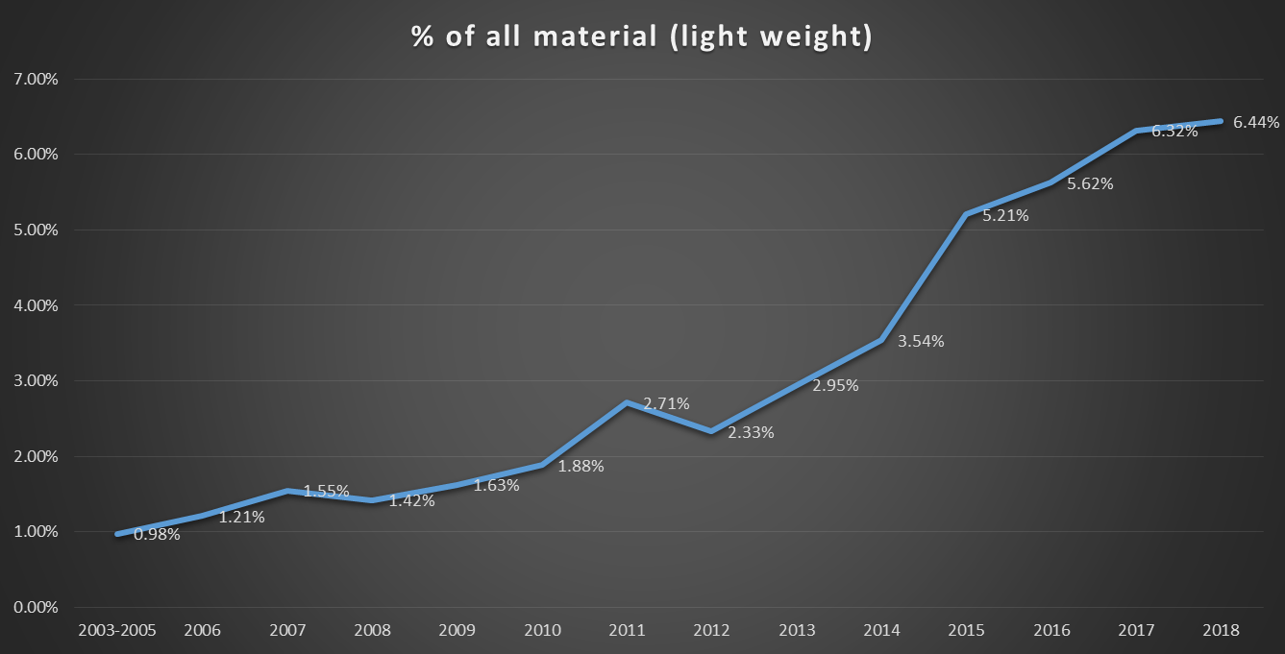
The impact of this on both the financial and diversion performance of municipal waste management systems has been significant.
But what does this mean when it comes to tracking waste reduction?
To better understand this question, we first have to understand the different reasons for why waste generation can change.

Systemic change
The “light weight” situation described earlier refers to systemic (province wide) change, that is independent of municipal characteristics, program design, or policy decisions. Statistically, we describe these changes as being “exogenous” to the system – it is happening as the result of external factors (producers light weighting packaging to reduce transportation costs, increase shelf life etc.). We expect these changes to affect all municipalities in the province (albeit to varying degrees).
As shown in figure 2, overall waste generation rates in Ontario are trending down:
Figure 2: Ontario Waste Generation Per Capita
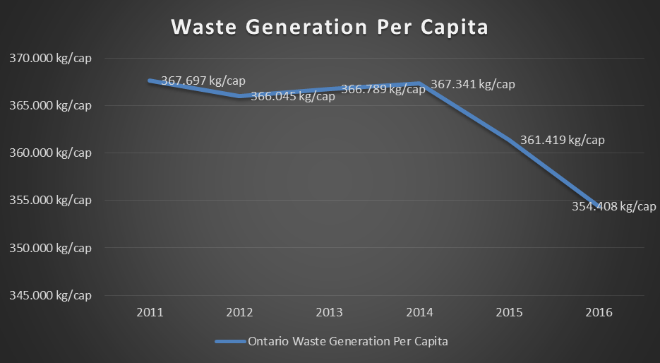
This trend is expected to persist into the future, with some estimates modeling waste generation to decrease by 20% by the year 2045.
From this, we can intuit that the systemic effect of package light weighting is placing downward pressure on municipal waste generation rates. However, given that some municipalities are not experiencing this phenomenon, we have to look at other factors affecting household waste generation.

Endemic Characteristics
Table 1 below summarizes waste generation per capita figures for a range of large urban municipalities in Southern Ontario (Taken from 2016 RPRA GAP Report).
Municipality | Residential Waste Generated Per Capita (kg)
HALTON, REGIONAL MUNICIPALITY OF | 375.110 kg/cap
TORONTO, CITY OF | 280.191 kg/cap
LONDON, CITY OF | 399.357 kg/cap
YORK, REGIONAL MUNICIPALITY OF | 315.532 kg/cap
HAMILTON, CITY OF | 397.118 kg/cap
PEEL, REGIONAL MUNICIPALITY OF | 360.560 kg/cap

As shown above, there is a significant degree of variance with respect to waste generation rates per capita. Some municipalities are significantly above or below the provincial average, and when examined over time, do not necessarily reflect the provincial trend of decreasing per capita generation rates (as an example, Peel generation rates are actually increasing over time).
This begs the question, why?
Waste generation rates are also effected by “endogenous” factors – the specific infrastructural and demographic characteristics of a municipality significantly affect waste generation rates. Table 2 below summarizes some of the key variables affecting waste generation:
Table 2: Factors affecting waste generation
Factor | Impact
Income | Positively correlated with waste generation and recovery
Age | Positively correlated with waste generation and recovery (until age 65, where generation per capita decreases and recovery per capita increases)
Gender | Men Generate more waste per capita, while woman divert more waste per capita
Population Density | Positively correlated with waste generation (and recovery)
Education | Positively correlated with diversion and participation in source separation programs
Immigration | First generation immigrants are less likely to participate in source separation programs, resulting in lower diversion rates per capita
Locality | Urban households generate and recovery more waste than rural households
Access to Curbside Collection (waste/recycling) | Positively correlated with waste generation and recovery
Dwelling Type | Single family households generate and recover more waste than MF households
Bin type | Households with access to curbside carts generate and recover more waste per capita
Pay as you throw/Bag limits | Presence of bag limit/PAYT decreases waste generation per capita, but increases recovery per capita

Given the heterogeneity with respect to the demographics and infrastructural characteristics of municipalities, it is expected that waste generation rates per capita will differ (at some times, significantly).
As an example, the City of Toronto has a waste generation per capita of 280.19kg/cap. This compares to a provincial average of 354kg/cap – Toronto’s results contravene conventional wisdom. One would think that Canada’s largest city would also produce the most waste per person – it is urban, has a higher median income relative to other municipalities, and the highest population density. However, given that almost half of all Toronto’s households are classified as multi-residential, the city generates and recovers significantly less material than other large urban municipalities.
When comparing audit results for both single and multi-family households, we see that MF homes generate approximately 18% less waste, and divert 41% less material than SF homes. This situation is exacerbated by the fact that new immigrants make up a greater proportion of Toronto’s population, resulting in lover diversion rates per capita. As such, due to the conditions endemic to Toronto, the city will have significantly different waste generation rates than other municipalities in the province.
Why this matters when it comes to measuring waste reduction is that the differences in waste generation described above are outside the control of the municipality. There is little Toronto, or any other city can do to change its demography or infrastructure.
Tracking waste reduction (or increases) without accounting for both systemic and endemic characteristics paints an incomplete picture. As an example, if a municipality is experiencing a 6% decrease in waste sent to landfill over 3 years, is that change attributable to systemic factors (light weighting is affecting all programs in the province), endemic change (the opening of a new college attracts more educated, higher income households who are more likely to participate in source separation) , or attributional (reduction in waste is directly attributed to a program or policy implemented by the city).

Attributional Change
Attributional change is the last factor affecting waste generation, and perhaps the most relevant for municipalities looking to track waste reduction.
Attribution refers to changes in overall waste generation/recovery attributed to a specific program or policy implemented by the municipality. These are the factors that are within a municipality’s control, and speak directly to the efficacy of a particular initiative. Some examples include the transition to a cart based program (expected to increase waste diversion), implementation of reuse programs such as lending libraries, curbside swaps, or repair cafes.
The challenge with measuring attributional change is that it needs to be specifically isolated from the exogenous and endemic factors that affect waste generation/disposal/recovery rates. To date, there has been no prescribed methodology for doing so – much of measuring waste reduction has been left to “guess work” and providing context to changes in household generation and recovery.
In Fall of 2018, York University, in collaboration with municipalities from across the Greater Toronto Area, undertook a study to provide guidance on how to specifically measure waste reduction.
This involves three stages:
- Controlling for “system wide” changes that are occurring across the market at a provincial or national level
- Controlling for socio demographic and infrastructural variables (shown in Table 2). Using a regression model to understand the causal effects of each variable on overall waste generation, “standardize” conditions across all municipalities to ensure we can compare like with like. This modeling forces all municipalities to have the same set of conditions (income per capita calibrated to the provincial average, assume a normalized split of multi residential to single family homes based on population weighting etc.). By eliminating endemic characteristics (or more specifically, controlling for them), we remove the factors that are beyond a municipalities direct control.
- Working with municipalities, develop a timeline for major programmatic changes or policy interventions, and determine whether those events correspond to a statistically significant change in waste reduction (This stage is ongoing, and will require collaboration with municipalities in the future)

Methodology

Data Sources
- RPRA GAP Diversion Rates (2011-2017)
- Statistics Canada 2016 Long Form Census

Regression Model
To determine what effects socio-demographic and infrastructural variables have on waste generation per capita, and waste diverted per capita, these variables are modeled as a function of the following variables:

Definition of Variables
- GR = Generation Rate (%)
- DR = Diversion Rate (%)
- FGEN = % of population who report as being born in Canada
- PAYT = 1 if municipality implements pay as you throw scheme (0 otherwise)
- URBAN = 1 if urban locality (0 otherwise)
- CURB = Percentage of households with access to curbside recycling collection (%)
- CART = Percentage of households with access to cart collection
- BWC = 1 if bi-weekly collection of recyclables and waste (0 otherwise)
- INC = Median income Per Capita ($)
- SEX = 1 if male, 0 if female
- SF = 1 if single family, 0 if multi
- AGE = Median Age
- EDUC = Percentage of Population with College education or higher (%)
- DEN = Population Density per square kilometer
- The linear econometric specification of waste generation per capita/waste diverted per capita is:
Equation 1 GR = β0 + FGENitβ1 +PAYTit β2 + CURBit β3 + INCitβ4 +AGEitβ5 + EDUCit β6 +DENit β7 + CARTitβ8 + SEXit β9 + SFit β10 + URBANitβ11 +BWCitβ12 + EDUCit β13 + TIMEt β8 +ai +uit
Equation 2 DR = β0 + FGENitβ1 +PAYTit β2 + CURBit β3 + INCitβ4 +AGEitβ5 + EDUCit β6 +DENit β7 + CARTitβ8 + SEXit β9 + SFit β10 + URBANitβ11 +BWCitβ12 + EDUCit β13 + TIMEt β8 +ai +uit

Time is the dummy variable for all years which diversion data is available (2012-2017), and ai and uit are the components for the unobserved disturbance resulting from systemic factors at time t.
Consistent with the standard statistical procedure, a Hausman test was conducted to see whether the models’ unique errors (ui) were correlated with the regressors. This was done to determine whether a fixed or random effects model should be used. The results show that cross-sectional variance components are zero, thereby confirming the null hypothesis. Hence, given the characteristics of the data used in this study, a random effects regressive model is considered the best available choice. A pooled OLS model is also estimated for the purposes of comparison, as the random effects model assumes strict exogeniety between the explanatory variables and disturbance term. If this assumption fails, a pooled OLS regression would produce more consistent results
Table 3 provides the summary statistics of our sample (Ontario Municipalities)
Table 3: Summary Statistics
Variable | Mean | Std. Dev | Min | Max
GR  DR | 354.08  174.22 | .2262  .2715 | 158.62  29.72 | 690.5  531.98
PAYT | .4890 | .5000 | 0 | 1
FGEN | .1718 | .263 | 0 | .475
CURB  CART | .4107  0.374 | .1921  0.1459 | 0  0 | 1  0.85
INC | 47780 | 4011 | 38006 | 57993
AGE | 38.40 | 2.906 | 32.00 | 41.996
EDUC | .2929 | .0778 | .1377 | .5242
DEN  SEX  SF  BWC | 14.141  0.484  0.8412  0.3156 | 132.90  0.11  0.391  0.294 | .1411  0  0  0 | 1127.7  1  1  0.86

Results
This section contains an excerpt of results for municipalities in the Greater Toronto Area. Full model output can be found in the regression output of the model created and owned by York University.
Figures 3-5 summarize the reported waste generation, waste diversion and waste disposed (per capita) for Toronto, Peel and York Region. These results are taken directly from the RPRA GAP Diversion reports

Figure 3: Waste Generation Per Capita

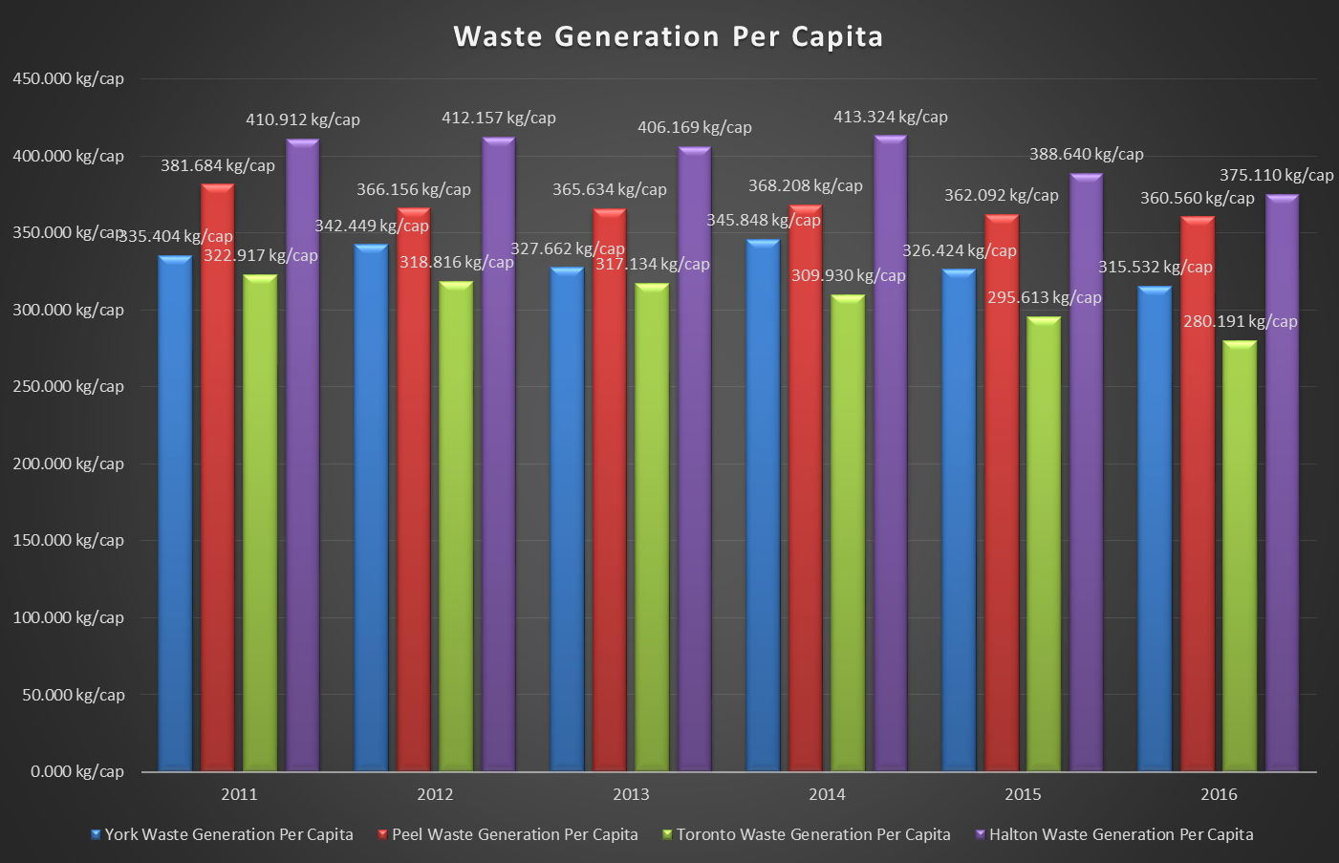

Figure 4: Waste Diverted Per Capita
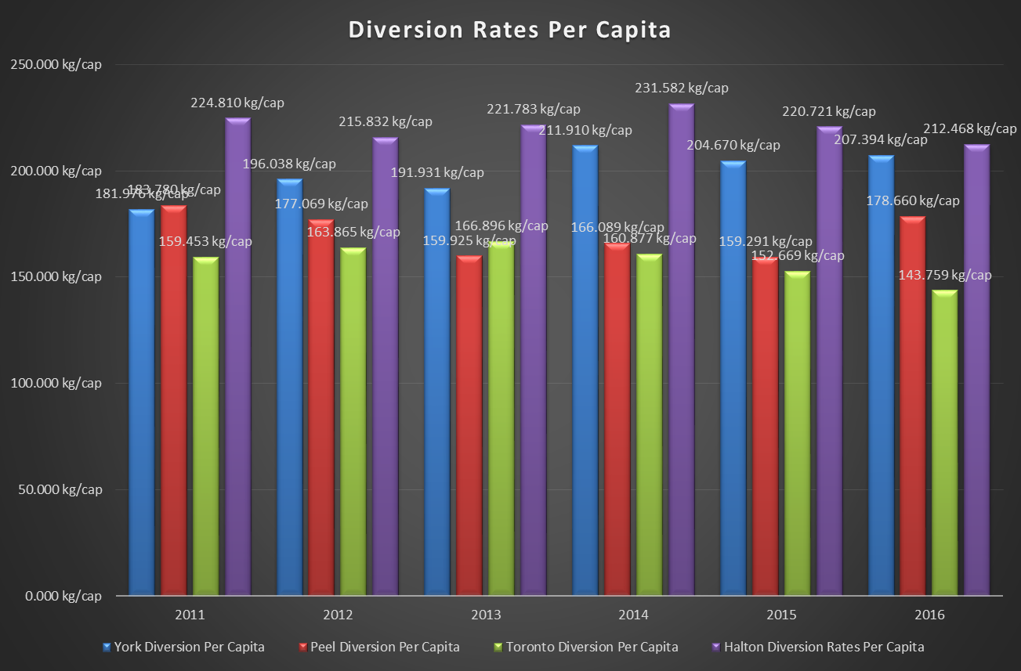
Figure 5: Waste Disposed Per Capita
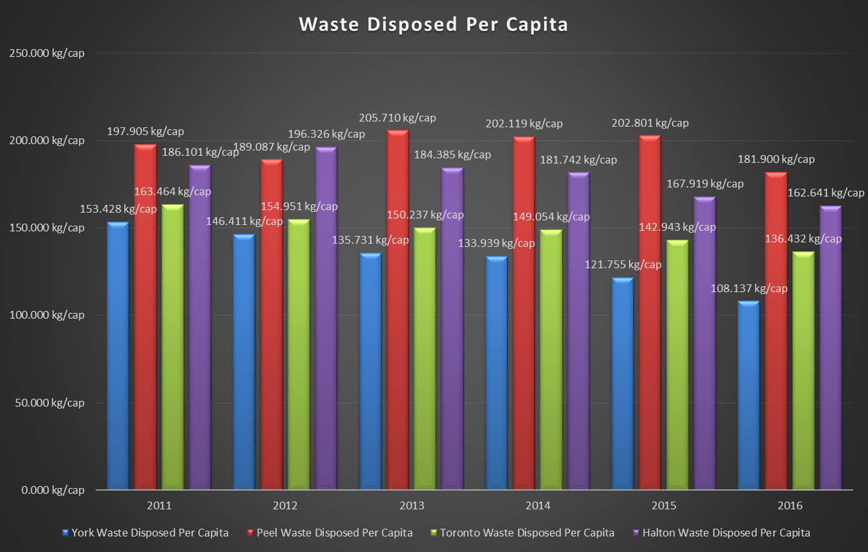

The above results are sort of a mixed bag – using the reported figures (without controlling for systemic or endemic factors), Halton both generates and diverts the most material per capita. Relative to other municipalities, Halton region tends to have a greater predominance of higher income single family homes, resulting in both increased consumption, and higher rates of participation in source separation programs. Conversely, Peel Region sends the most amount of material to landfill, while York Region sends the least amount of material to landfill. Toronto lies squarely in the middle – while being a relatively poor performer in diversion rates per capita, they still manage to have a clear downward trend on the amount of material being sent to landfill.
What happens when we do control for systemic and endemic factors, using the regression model described above?
Figures 6-8 below summarize the results of our adjusted regression modeling.
As shown, Halton continues to generate and divert the most amount of waste per capita. However, once controlling for sociodemographic and infrastructural variables, Toronto’s diversion rate per capita significantly increases, while Peel experiences a significant reduction in waste generated per capita.
York continues to be the best performer among their peer group, with higher diversion rates per capita, and the lowest amount of material sent to landfill. Of note, after standardizing each municipality by controlling for endemic and systemic factors, all three exhibit decreases in waste being sent to landfill (based on the plotted trend line). This suggests that even when we control for factors such as light-weighting and demographic/infrastructural differences, all three municipalities achieve waste reduction (with varying degrees of success).
What remains unclear at this time is what specifically about GTA programs has resulted in this decrease in waste. Better understanding the causal affects between policy/program and waste reduction requires close collaboration with the municipality – the final step in this exercise is attempting to overlay policies that have been implemented over the past 7 years, with the trends we observe in our standardized data set. As an example, between 2015 and 2016, York region experienced a 20kg drop in waste disposed per capita (a statistically significant result). What measures were taken by the region during this time that could explain this change?
Combining both quantitative (regression model and data standardization) with qualitative approaches (context surrounding programs and policies, and when they were implemented), is what will provide municipalities insight into how and why waste generation rates have changed, and how to measure waste reduction.

Moving Forward

Measuring waste reduction is a difficult, but not impossible task. The most important part is developing a prescribed methodology for doing so. Municipalities are encouraged to either undertake their own analysis for controlling endemic/systemic variables using the aforementioned methodology, or engage with the university (or preferred vendor) to collaboratively carry out that exercise.
Figure 6: Adjusted Waste Generated Per Capita
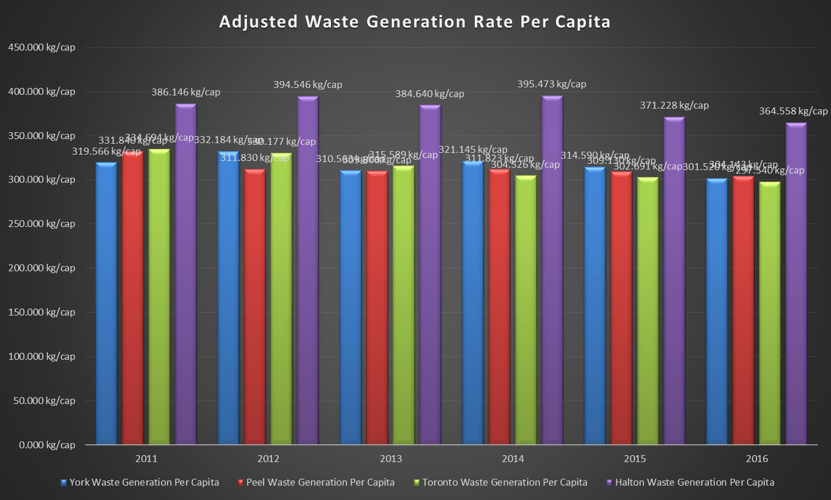

Figure 7: Adjusted Diversion Per Capita
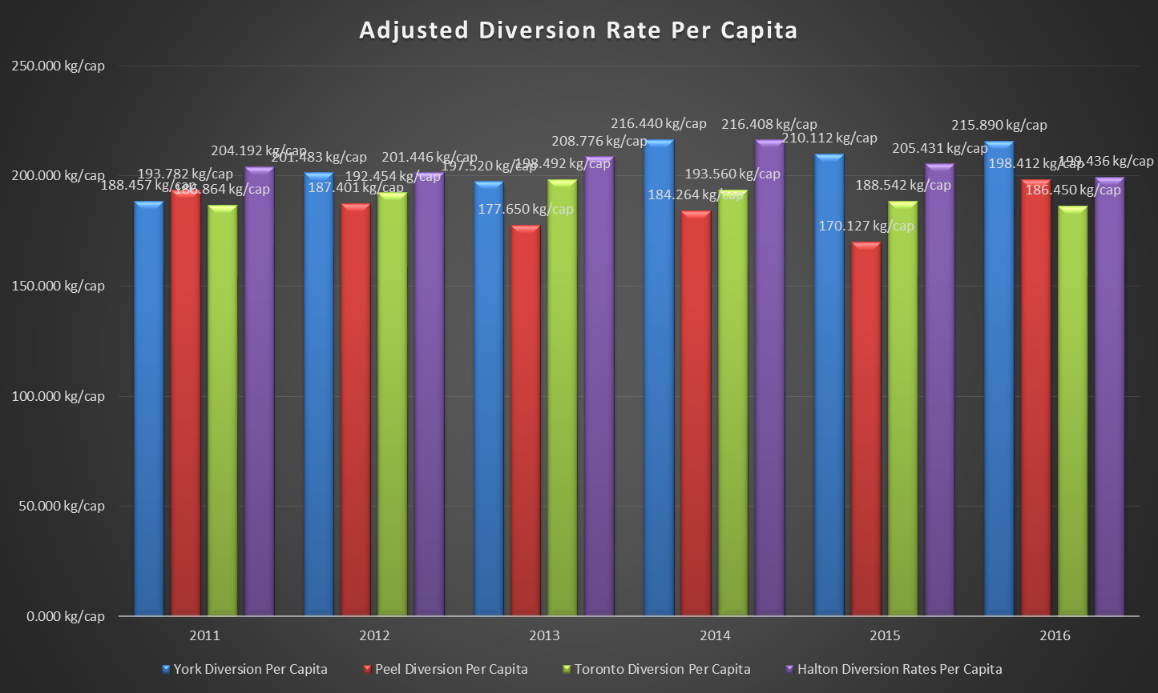

Figure 8: Adjusted Waste Disposed Per Capita
